DV Station Data Analysis Program

Documentation and how TO USE

Table of Contents

Overview 3

DV Test Stations 3

Current Limits 3

Analysis 4

1) Temporal Plotting 4

2) Current Histograms 5

3) Summary Tables 6

4) Out of Spec Data 7

How to Use 8

Test Data Parameters 8

► Data Folder 8

► Limits File 8

► Temperatures 9

► Boards 9

► Analysis 9

► Conditions 9

► Tolerances 9

► Test Name 10

Multimode Explained 10

Analyze 11

Errors 11

Real Time Mode 12

Limits Files in Detail 13

Board and Module Information 13

► Module Names 13

► LED Bins 13

► Outage Link 13

Limits for Each Mode 15

► Multimode and Current Sharing 15

► Different Limits for Different LED Bins 15

Altering and Saving Limits Files 15

► Add/Remove Board 15

► Add/Remove Mode 16

► Add/Remove Outage 16

► Add/Remove Temperature 16

► Add/Remove Voltage 16

Creating and Editing Limits Files 17

Installing the software 18

Getting Started 18

Dependencies and Version Control 18

Building an executable 18

Issues and workarounds 19

Miscellaneous 19

# **Overview**

This program analyzes raw environmental test data for automotive lighting systems. The tests expose lighting systems to various temperature profiles while the systems are powered. Each test system is comprised of many modules (e.g. - Turn, DRL, Park, Outage, etc.) and can be run in different modes (e.g. – Park only, Turn only, Park+Turn, DRL+Park, etc.). These various modes are excited at different voltages throughout testing. The primary function of this project is to analyze the distributions of current for each temperature/mode/voltage condition.

Reference to Labview documentation for more detail…

## DV Test Stations

The raw data that this program analyzes is produced by our DV Test Stations. These test stations may consist of any number of power supplies, DAQ systems, control and monitoring (C&M) boards, and outage boards. Presently, most of our stations consist of 2 power supplies, 2 DAQ systems, and 6 boards.

The test lighting systems are wired to the boards and currents (or voltages) are measured across high precision shunt resistors. Each board is used for a single module in the system. For instance, a lighting project may be set up on the boards of a DV Test Station like this:

Board 1 - Low Beam

Board 2 - High Beam

Board 3 - DRL

Board 4 - Park

Board 5 - Turn

Board 6 - Outage

A Labview program defines the functional cycle of testing (which modules are powered and when) and outputs raw DAQ voltage and current data of each system for each board along with chamber and product temperature data.

**Current Limits**

For each lighting project current limits are established for the various temperature/mode/voltage conditions. These limits can be used for any particular environmental test. These limits are stored in an html file and read by the program. Limits are excellent for comparing the measured currents to an expected or acceptable range. They also aid in recognizing subtle failures.

Not all LEDs are created equal. Some LEDs are more efficient than others (the same current will produce greater light output) and so LEDs are allocated into different bins. LED binning is accounted for in the limits files so that different current limits can be used for samples of the same module type but different LED bin.

**Analysis**

The analysis consists of four components:

1. Temporal Plotting
2. Current Histograms
3. Summary Tables with basic statistics and comparison to limits
4. Out of spec data

**1) Temporal Plotting**

A set of temporal subplots may be created (see Figure 1 for an example):

* Voltage and functional cycle
* Temperature profile
* Current measurements for each mode that is present in test

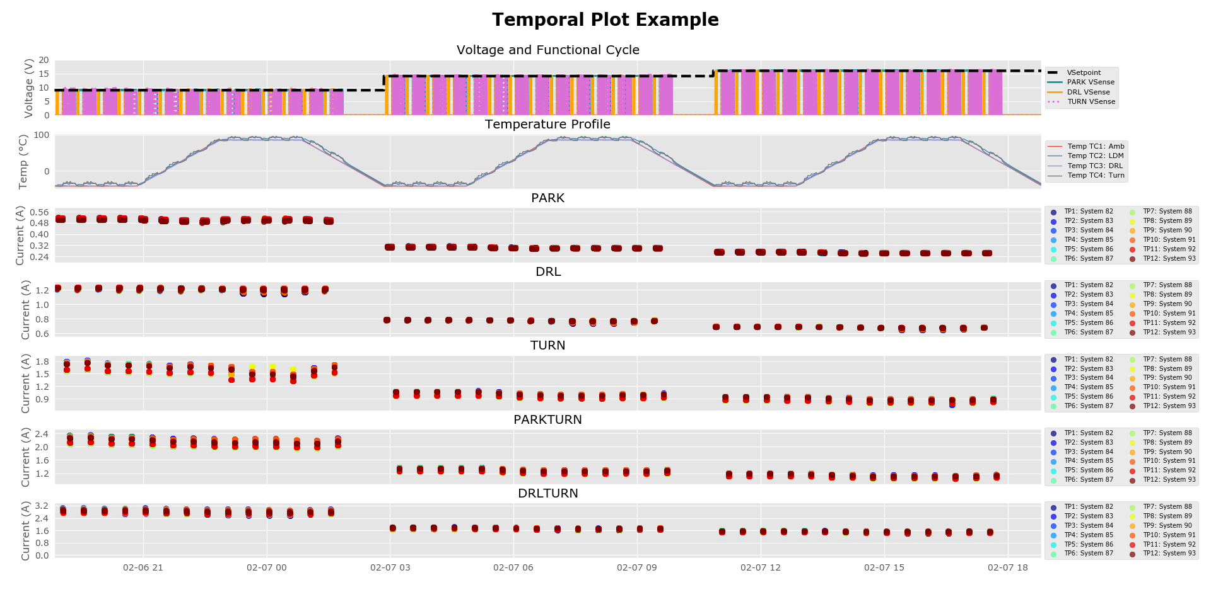

Figure . Example of a temporal plot created by program

### 2) Current Histograms

Histograms may be created to visualize the distribution of currents at different test conditions. If provided, limits are drawn as vertical dashed lines. These may be created from the test population as a whole or on a system by system basis. See Figure 2 and Figure 3 for examples. Note that these images are not saved by default. Use the save button to save an image and make sure to resize the window to the desired size before doing so.

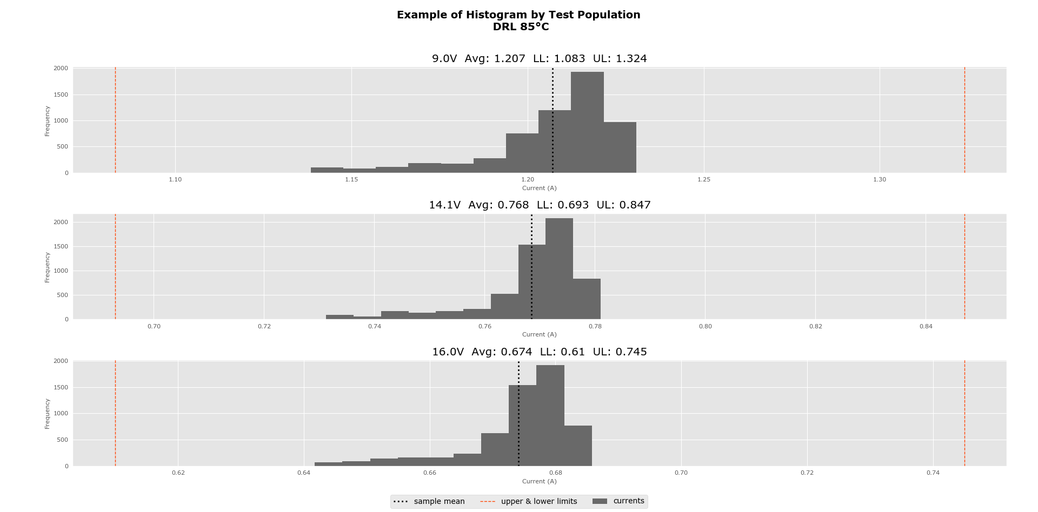

Figure . Histogram using the currents of the whole test population in DRL mode at 85°C

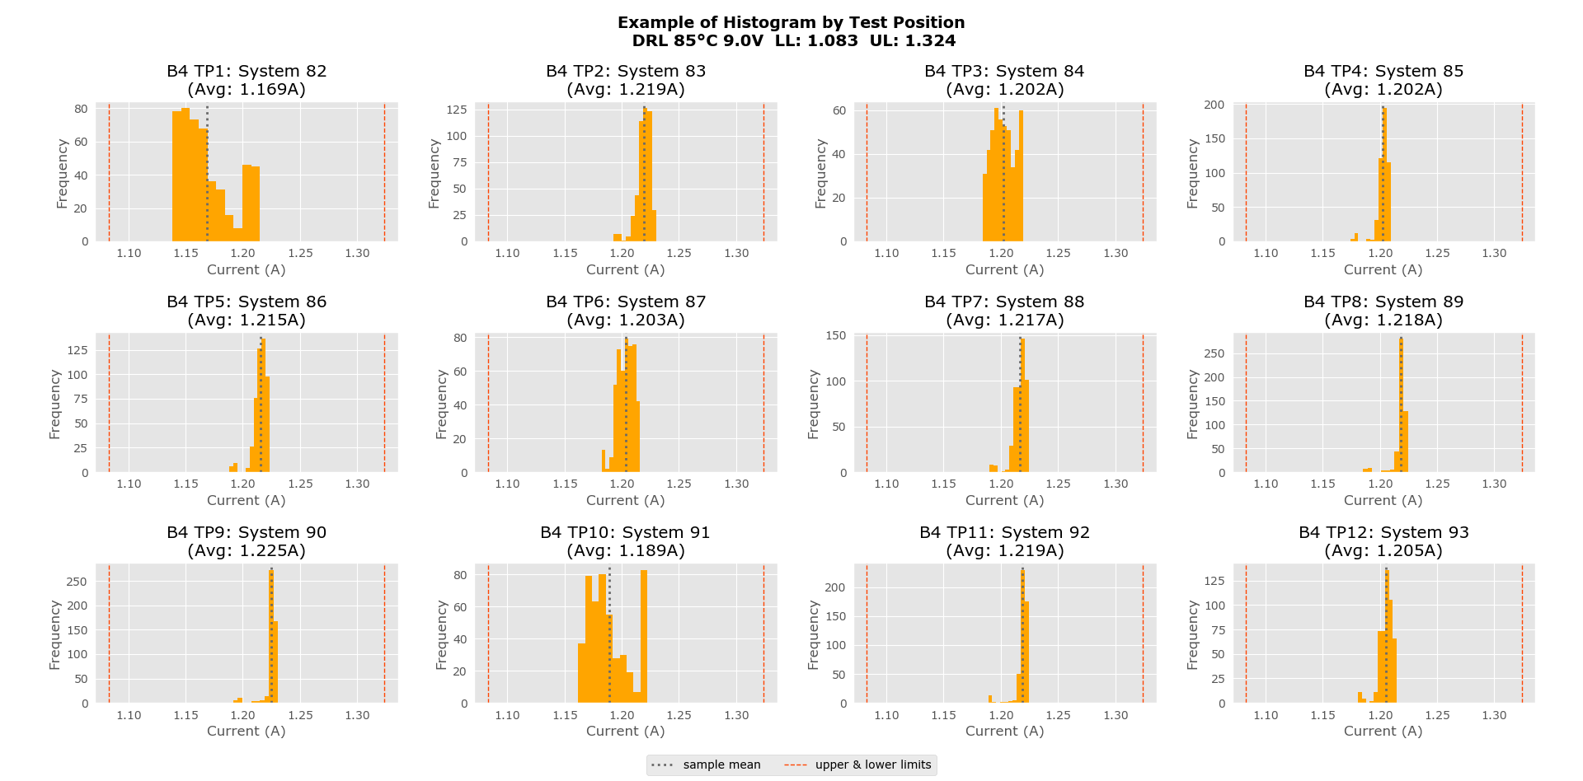

Figure . Histograms using the isolated currents of each test position in DRL mode at 85°C and 9V

### 3) Summary Tables

An xml file is created with the temperature data and basic statistics for the various temperature/mode/voltage conditions for each system. A small table at the top summarizes the minimum and maximum test temperatures, see Table 1. Nested tables are created for each mode present in each temperature entered for analysis by the user. See Table 2 for an example.

By default the xml data tables are saved in the “!output” folder where the main application executable is located. There is also a “templates” folder inside the “!output” folder that contains a couple xsl and css files that describe the layout and styling for displaying these xml files in a browser. Do not delete these templates.

|  |  |  |
| --- | --- | --- |
| **Thermocouple** | **Min (°C)** | **Max (°C)** |
| Temp TC1: Amb | -43.82 | 85.58 |
| Temp TC2: LDM | -42.21 | 94.52 |
| Temp TC3: DRL | -42.63 | 85.69 |
| Temp TC4: Turn | -43.07 | 96.29 |

Table . Test temperatures summary table

|  |  |  |  |  |  |  |  |  |  |  |  |  |  |  |
| --- | --- | --- | --- | --- | --- | --- | --- | --- | --- | --- | --- | --- | --- | --- |
| **Example Table: TURN at -40°C** | | | | | | | | | | | | | | |
| **9.0V** | | | | | | | | | | | | | | |
| **Limits: 1.571A to 1.92A** | | | | | | | | | | | | | | |
| **Name:** | Vsense 1st | Vsense Last | TP1: System 82 | TP2: System 83 | TP3: System 84 | TP4: System 85 | TP5: System 86 | TP6: System 87 | TP7: System 88 | TP8: System 89 | TP9: System 90 | TP10: System 91 | TP11: System 92 | TP12: System 93 |
| **Min:** | 9.111 | 8.994 | 1.536 | 1.752 | 1.561 | 1.718 | 1.568 | 1.745 | 1.535 | 1.697 | 1.566 | 1.721 | 1.564 | 1.701 |
| **Max:** | 9.395 | 9.292 | 1.596 | 1.833 | 1.619 | 1.787 | 1.627 | 1.814 | 1.593 | 1.763 | 1.624 | 1.789 | 1.627 | 1.77 |
| **Avg:** | 9.333 | 9.229 | 1.549 | 1.772 | 1.574 | 1.734 | 1.581 | 1.76 | 1.548 | 1.711 | 1.578 | 1.736 | 1.579 | 1.717 |
| **St dev:** | 0.092 | 0.093 | 0.018 | 0.021 | 0.018 | 0.021 | 0.019 | 0.021 | 0.018 | 0.02 | 0.019 | 0.021 | 0.018 | 0.02 |
| **Total Count:** | 184 | 184 | 184 | 184 | 184 | 184 | 184 | 184 | 184 | 184 | 184 | 184 | 184 | 184 |
| **Count Out:** | 0 | 0 | 165 | 0 | 135 | 0 | 88 | 0 | 165 | 0 | 135 | 0 | 121 | 0 |
| **Percent Out:** | 0.0% | 0.0% | 89.67% | 0.0% | 73.37% | 0.0% | 47.83% | 0.0% | 89.67% | 0.0% | 73.37% | 0.0% | 65.76% | 0.0% |
| **Check Data:** | G | G | Out of Spec | G | Out of Spec | G | Out of Spec | G | Out of Spec | G | Out of Spec | G | Out of Spec | G |
| **14.1V** | | | | | | | | | | | | | | |
| **Limits: 0.94A to 1.148A** | | | | | | | | | | | | | | |
| **Name:** | Vsense 1st | Vsense Last | TP1: System 82 | TP2: System 83 | TP3: System 84 | TP4: System 85 | TP5: System 86 | TP6: System 87 | TP7: System 88 | TP8: System 89 | TP9: System 90 | TP10: System 91 | TP11: System 92 | TP12: System 93 |
| **Min:** | 14.159 | 14.1 | 0.971 | 1.084 | 0.975 | 1.071 | 0.979 | 1.082 | 0.966 | 1.059 | 0.976 | 1.07 | 0.978 | 1.061 |
| **Max:** | 14.345 | 14.283 | 0.989 | 1.102 | 0.99 | 1.087 | 0.993 | 1.099 | 0.981 | 1.076 | 0.991 | 1.087 | 0.994 | 1.078 |
| **Avg:** | 14.28 | 14.22 | 0.977 | 1.091 | 0.981 | 1.077 | 0.984 | 1.089 | 0.972 | 1.066 | 0.982 | 1.076 | 0.984 | 1.068 |
| **St dev:** | 0.078 | 0.078 | 0.006 | 0.007 | 0.006 | 0.006 | 0.006 | 0.006 | 0.005 | 0.006 | 0.006 | 0.006 | 0.006 | 0.006 |
| **Total Count:** | 181 | 181 | 181 | 181 | 181 | 181 | 181 | 181 | 181 | 181 | 181 | 181 | 181 | 181 |
| **Count Out:** | 0 | 0 | 0 | 0 | 0 | 0 | 0 | 0 | 0 | 0 | 0 | 0 | 0 | 0 |
| **Percent Out:** | 0.0% | 0.0% | 0.0% | 0.0% | 0.0% | 0.0% | 0.0% | 0.0% | 0.0% | 0.0% | 0.0% | 0.0% | 0.0% | 0.0% |
| **Check Data:** | G | G | G | G | G | G | G | G | G | G | G | G | G | G |
| **16.0V** | | | | | | | | | | | | | | |
| **Limits: 0.824A to 1.007A** | | | | | | | | | | | | | | |
| **Name:** | Vsense 1st | Vsense Last | TP1: System 82 | TP2: System 83 | TP3: System 84 | TP4: System 85 | TP5: System 86 | TP6: System 87 | TP7: System 88 | TP8: System 89 | TP9: System 90 | TP10: System 91 | TP11: System 92 | TP12: System 93 |
| **Min:** | 16.061 | 16.01 | 0.858 | 0.954 | 0.861 | 0.943 | 0.862 | 0.954 | 0.853 | 0.934 | 0.861 | 0.942 | 0.863 | 0.935 |
| **Max:** | 16.208 | 16.155 | 0.873 | 0.966 | 0.871 | 0.954 | 0.872 | 0.965 | 0.863 | 0.944 | 0.871 | 0.954 | 0.873 | 0.947 |
| **Avg:** | 16.162 | 16.11 | 0.862 | 0.959 | 0.865 | 0.947 | 0.866 | 0.958 | 0.856 | 0.938 | 0.865 | 0.947 | 0.866 | 0.94 |
| **St dev:** | 0.061 | 0.061 | 0.004 | 0.004 | 0.003 | 0.004 | 0.003 | 0.004 | 0.003 | 0.004 | 0.003 | 0.004 | 0.003 | 0.004 |
| **Total Count:** | 181 | 181 | 181 | 181 | 181 | 181 | 181 | 181 | 181 | 181 | 181 | 181 | 181 | 181 |
| **Count Out:** | 0 | 0 | 0 | 0 | 0 | 0 | 0 | 0 | 0 | 0 | 0 | 0 | 0 | 0 |
| **Percent Out:** | 0.0% | 0.0% | 0.0% | 0.0% | 0.0% | 0.0% | 0.0% | 0.0% | 0.0% | 0.0% | 0.0% | 0.0% | 0.0% | 0.0% |
| **Check Data:** | G | G | G | G | G | G | G | G | G | G | G | G | G | G |

Table . Example table from PTC test summarizing measurements in Turn mode at -40°C

The tables summarize the measurements collected for each test system in a particular mode at a particular temperature. Each column contains information and statistics on the measured voltages or currents of a specific test system. The statistics include the following parameters which are listed and described below:

* **Min**: minimum recorded measurement
* **Max**: maximum recorded measurement
* **Avg**: average recorded measurement
* **St dev**: standard deviation
* **Total Count**: the total count of scans for this system
* **Count Out**: the total count of scans that were out of the specified limits for this system
* **Percent Out**: the percentage of data that was out of spec for each system
* **Check Data**: Information on whether any data for the system was out of spec. “G” signifies “good” or that the system’s currents were within specified limits. “Out of Spec” signifies that at least some of the system’s currents were out of the specified limits. “NA” indicates that limit analysis was not performed.

These tables may be displayed on a web browser via a template xsl file that defines the layout. A hide button at the top of the page will hide many of the rows of statistics so that simpler tables may be copied into test reports.

### 4) Out of Spec Data

A txt file containing only data scans that included out of spec data. This is useful if the user would like to take a closer look at the raw data to troubleshoot a specific failure that occurred during testing.

# **How to Use**

A GUI is provided for users to run DV Station test analysis. See Figure 4 for GUI display. There are a number of test parameters that the user must enter to define the test data to analyze and the type of analysis to perform.

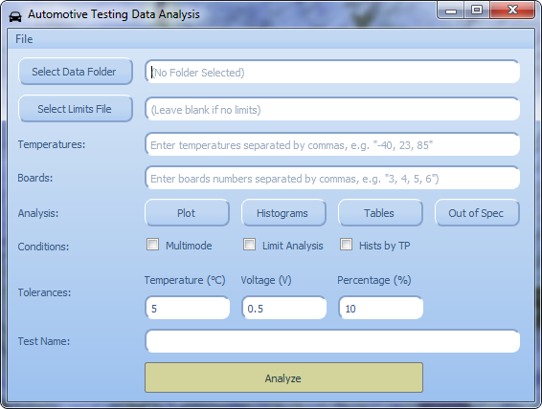

Figure . DV Test Analysis Program GUI

**Test Data Parameters**

**► Data Folder**

Required. Click the “Select Data Folder” button to navigate to and select the folder that contains the raw data to be analyzed.

**► Limits File**

Optional. If limit analysis is desired a limits file must be selected. Click the “Select Limits File” button to navigate to and select the limits file. For more information on limits files, see “Limits Files in Detail” section.

**► Temperatures**

Required. Type in the chamber ambient temperatures (separated by commas) at which you would like to analyze the test data.

**► Boards**

Required. Type in the DV Station board numbers (integers separated by commas, e.g. – “3, 4, 5”) that were used for the test.

**► Analysis**

Required. Toggle any (at least one) of the following buttons to add it to the analysis to be performed:

* *Plot*: A series of temporal plots including the functional cycle, the temperatures of ambient and product thermocouples, and the current measurements for each mode powered in test
* *Histograms*: Histograms for the recorded currents in each mode at each voltage and temperature
* *Tables*: Tables for each mode summarizing the minimum and maximum measurements and whether data was out of spec (if doing limit analysis)
* *Out of Spec*: A txt file including only the raw data that is out of spec (if doing limit analysis)

**► Conditions**

Optional. These parameters tweak conditions of the analysis. Check all that apply.

* *Multimode*: Check this box if the test product exhibits current sharing between modules (e.g. – Park+Turn). See “Multimode Explained” section for more details. Also, see “Limits Files in Detail” for how to use multimodes with limit analysis.
* *Limit Analysis*: Check this box if current limit analysis is desired. A limits file must also be selected for this analysis to run. The user may also supply a limits file and not check this limit analysis box; in this case limit analysis will not run but information such as the module names (which is also included in the limits files) will be pulled.
* *Hists by TP*: By default current histograms are created of the whole test population. Check this box to create histograms for each test position system instead.

**► Tolerances**

Optional. Default tolerances are provided but may be altered by the user.

* *Temperature*: Tolerance for test analysis at each temperature (e.g. – if the tolerance is 5°C then for 23°C all data scans within the range 18-28°C will be included in 23°C analysis)
* *Voltage*: Tolerance that determines whether a voltage sense measurement is considered within specification
* *Percentage*: Histograms will include dashed vertical lines ± the entered percentage from the population mean (only used if limits are not provided)

**► Test Name**

Required. Enter a descriptive name of the test. This name is included as a title in the temporal plot, histograms, and summary tables.

**Multimode Explained**

If the multimode condition checkbox is left blank, then each test board is analyzed separately. That is, it does not matter what combinations of boards are on or off at any given time in the test; they will be analyzed separately.

If the multimode condition is checked, the program will analyze by board combinations (“multimodes”) that exist in the data. Currently it only analyzed two board multimodes (it will not analyze board mode combinations of more than 2 boards, e.g. – B1+B2+B3). For instance if B1 and B2 are on at the same time for portions of the test (and the other boards are off during this time), then B1+B2 will be treated as a multimode and analyzed separately. Single board modes will still be analyzed but only if and when it is the only board on for part of the test.

Let’s take a look at an example.



Table . Example functional cycle

Suppose our test uses the functional cycle in Table 3. The analysis would be the following:

* Modes for analysis: B1, B2, B5, B6, B1+B2, B3+B5
* Ignored: B1+B2+B3+B4 (this mode has more than 2 boards on)

Outage boards are always isolated from current boards and are analyzed separately, regardless of whether or not the multimode condition is checked. However, if limit analysis is not being used and there are outage boards present, it is recommended that you do not select the outage boards for analysis. This is because there is no way (without a limits file) to denote that a test board is an outage board.

When designing functional cycles with multimodes for your tests, keep in mind the logic of the analysis program. For instance, if you want to have B1+B2 and B3+B4 be analyzed modes, make sure to give them their own functional cycle steps (with all other boards off). If you must have more than 2 boards on at once, you may run multiple analyses (selecting different boards to analyze for each) as a workaround.

**Analyze**

Once all parameters have been entered, click the “Analyze” button at the bottom of the GUI to conduct analysis on the selected test data.

**Errors**

If any errors occur while running the program they will be printed to the terminal window. Most errors are handled and a user feedback message describing the problem will be displayed. See Figure 5 for an example.

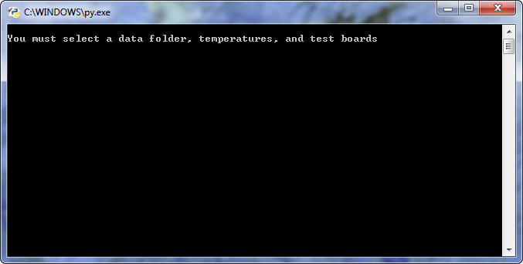

Figure . Example of an error displayed in the command line window

**Real Time Mode**

The user may run the program in a semi real time mode to analyze data on a test station computer for an ongoing test. To switch the program to this mode, navigate to File > Real Time.

The GUI skin will change to indicate the program has switched to real time mode. This mode permits analysis summary tables only (plotting and histograms are not permitted). “Tables” is preselected under analysis and many parameters are disabled and greyed out. See Figure 6. The user must provide analysis temperatures and a test name. The user may provide a limits file and tweak analysis conditions or tolerances if desired. The analysis will automatically re-run each time new data files are created by Labview and display the table summaries of the data collected thus far.

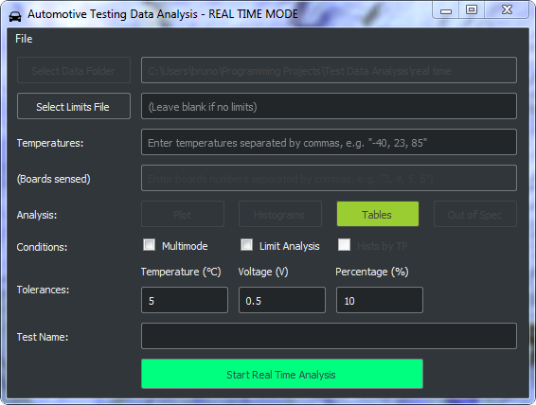

Figure . DV Test Station Analysis GUI in Real Time Mode

# **Limits Files in Detail**

Current limits are established for each lighting project at various temperature/mode/voltage environmental testing conditions. Their purpose is to provide an expected range for comparison with measured current data. This helps recognize both hard and soft failures. Limits can be used for any environmental test and are stored in an html file, which is read by the program. Limits also contain information about the project modules and how the test station boards were used for a particular test.

See Figure 7 for an example of a limits file.

**Board and Module Information**

At the top of the limits file, there is a table containing test station boards and module information. The tables show which boards were used for each module to measure voltages and currents, the names of the modules, the LED bins used for each module (if any), and which module(s) are linked to an Outage signal (if any).

**► Module Names**

The module names are listed under the “Module” column and line up with the test station board number that it was wired to for test measurements.

**► LED Bins**

The “LED Bin” column lists the different LED bins (if any) used for each module separated by spaces. For example if the Turn module uses 8J and 6K LEDs, then “8J 6K” would be listed for that module.

**► Outage Link**

Outage is a signal relayed to the car’s main control that indicates if a certain light module is on or off. It is often linked to Turn. Not all automotive lighting systems have Outage. The “Outage Link” column indicates which light module is linked to Outage.

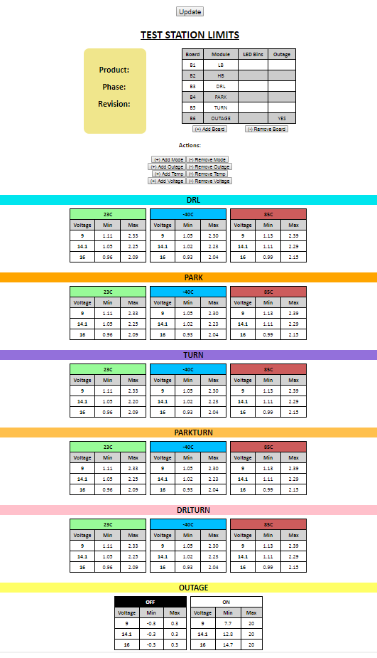

Figure . Example of a limits file

**Limits for Each Mode**

For each mode, a set of tables stores current limits at different voltages and temperatures. A large color-coded header (with the mode name) is displayed above each mode limits section. Each one of these mode sections contains tables that store the current limits for that mode under different voltage/temperature conditions.

**► Multimode and Current Sharing**

Some lighting projects include modules that share current and require analysis of currents in multimode conditions (e.g. – Park+Turn). By convention the name of a multimode is the appended names of each module in the multimode (no spaces, order doesn’t matter). For instance, for the multimode Park+Turn the name and header would be “PARKTURN”.

**► Different Limits for Different LED Bins**

Not all LEDs are created equal. Some LEDs are more efficient than others (the same current will produce greater light output) and so they are allocated into different brightness bins. LED binning may be accounted for in limits files so that different current limits can be used for samples of the same module type but different LED bin. LED bin labels may be entered for each module in a table at the top of a limits file.

For example if the TURN module uses 8J and 6K LEDs, enter “8J 6K” for that module. Then, instead of listing a single TURN container for all of its current limits, list two TURN containers labeled “8J TURN” and “6K TURN” each with different current limits. Additionally, the Labview test program must also have the LED bin(s) entered before the system name (e.g. – “8J 6K System 41”). This convention ensures that currents for systems with binning are compared to the correct limits.

**Altering and Saving Limits Files**

Note: Limits files are only editable/savable in Chrome, Firefox, and Edge web browsers. It will not work using Internet Explorer.

Buttons are provided in the limits files to allow the user to alter the file. Boards, modes, temperatures, and voltages can be added or removed.

**► Add/Remove Board**

Click “(+) Add Board” to add a board to the board module information table. A new row with an incremented board number, the default name “Module”, and blank LED Bins/Outage Link fields will be appended to the end of the table. The fields are editable so simply click in the table cells to change the module name or add text to the other fields.

Click “(-) Remove Board” to remove the last board from the table. This action is disabled if there are only three boards left in the table.

**► Add/Remove Mode**

Modes may be added or removed by clicking the “(+) Add Mode” or “(-) Remove Mode” buttons. This will prompt a dialog window asking the user to enter the name of the mode, which will then be deleted or added accordingly. Note that the mode names must be a module name (or combination of module names, e.g. - “PARKTURN”) from the board module information table.

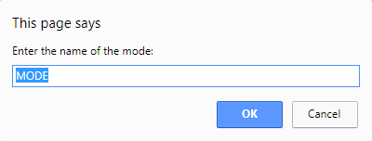

**► Add/Remove Outage**

Outage may be added or removed by clicking the “(+) Add Outage” or “(-) Remove Outage” buttons. An outage container will be added at the end of the file with two tables for limits inputs: an ON table and an OFF table. The table fields may be filled just like a mode current limits table.

**► Add/Remove Temperature**

Temperatures may be added or removed by clicking the “(+) Add Temp” or “(-) Remove Temp” buttons. This will prompt a dialog window asking the user to enter a temperature in degrees Celsius of the form “95C”. The temperature will then be deleted or added accordingly.

When a temperature is added, a current limit table at that temperature is created in each mode section using the voltages present in the file. When a temperature is removed, if the entered temperature is present in the file then those tables will be removed.

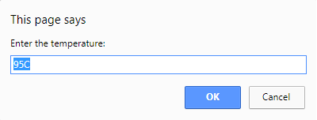

**► Add/Remove Voltage**

Voltages may be added or removed by clicking the “(+) Add Voltage” or “(-) Remove Voltage” buttons. This will prompt a dialog window asking the user to enter a voltage (integer or float), which will then be deleted or added accordingly. The voltage will be added/removed from each current table in the document. A user will be prevented from adding a voltage that is already present in the file or removing one that is not.

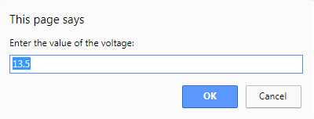

**Creating and Editing Limits Files**

All current and outage fields in limits tables are editable. To change a current or outage voltage simply click in the cell and type in a new value.

After making changes click the “Update” button at the top of the file. This will update all the values and ids on the page but will not save it. To save the changes, press “Ctrl+s” on the keyboard and select the file format “webpage, complete.” You may save over the current file or rename it and save as a new file.

There is a template limits file on the network with a blank framework.

# **Installing the software**

## Getting Started

Python (any subversion of 3.5) must be installed on your computer in order to use this data analysis program: <https://www.python.org/>

### Dependencies and Version Control

A github repository of the data analysis software program is hosted at <https://github.com/OsramAutomotive/test-analysis/tree/averna>. Download this repository's code to your local environment. Ensure you have pip installed and from the command line run the following command to collect the required python packages:

pip install -r requirements.txt

The “requirements.txt” file lists all the required packages and the pip module collects them. At this point, you will be able to run the program in your local Python environment.

### Building an executable

To build an executable, navigate to the project root folder in the terminal and run the command:

pyinstaller __main__.spec

This command will create a series of log and working files in the “build” folder and most importantly an executable in the “dist” folder. This “dist” folder contains everything required to run the software; the executable, dlls, and other files the program relies upon. This folder may be copied to any computer with a Windows operating system and the executable may be run from there.

# **Issues and workarounds**

* Limits may be provided to pull module names but not run analysis if you like (provide limits but do not check “limit analysis” box)
* Explain multimode, current sharing in detail
* Summary tables (statistics and hide button)

# **Miscellaneous**

* Limits may be provided to pull module names but not run analysis if you like (provide limits but do not check “limit analysis” box)
* Explain multimode, current sharing in detail
* Summary tables (statistics and hide button)